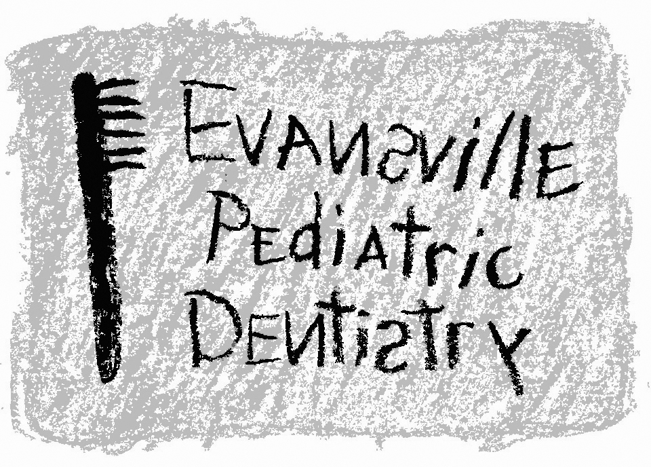
Jeffrey A. Hiester, D.D.S.
EAST WEST
7200 E. Virginia Street 2345 W. Franklin Street #101 Evansville, IN 47715 Evansville, IN 47712
(812) 479-8609 (812) 401-6095

CONSENT FOR DENTAL TREATMENT UNDER GENERAL ANESTHESIA

I, ___________________________, give consent for _______________________________ to receive dental treatment under general anesthesia in the operating room at Surgicare Outpatient Surgical Center.

Dental treatment will be provided by Jeffrey A. Hiester, D.D.S. and dental assistants under his supervision.

The following dental services are expected to be provided, but not limited to:

- dental examination
- dental prophylaxis and fluoride
- dental radiographs
- dental restorations
- crowns (stainless steel and/or composite)
- pulpal theray
- extractions
- other: ______________________________________

I understand that it may be necessary to alter the treatment plan during the surgery and I give permission to provide alternative and/or additional procedures as deemed necessary by Jeffrey A. Hiester, D.D.S.

The nature of the dental treatment, the risks, and the alternative treatment options have been explained to me. Also, the risk and alternative of refusing dental treatment has been explained.

All patients undergoing general anesthesia are subject to risk of medical complications including but not limited to: sore throat, nausea and vomiting, respiratory and cardiovascular problems, malignant hypothermia, and death.

Necessary medical treatment will be provided by members of the hospital staff, your child’s pediatrician, or your family physician.

I UNDERSTAND AND HAVE HAD AMPLE OPPORTUNITY TO DISCUSS ALL OF THE ABOVE INFORMATION. MY QUESTIONS HAVE BEEN ANSWERED. I REQUEST TREATMENT FOR MY CHILD.

I am the patient’s mother / father / legal guardian.

Name ____________________________________________________ Date _______________

I, Jeffrey A. Hiester, D.D.S., have explained all the above. I have also delivered a patient instruction sheet and explained it to the best of my ability.

Name ____________________________________________________ Date _______________

